Mount Rainier National Park
55210 238th Avenue East
Ashford, WA 98304
360-569-6501 phone
www.nps.gov

National Park Service
U.S. Department of the Interior
Mount Rainier National Park News Release

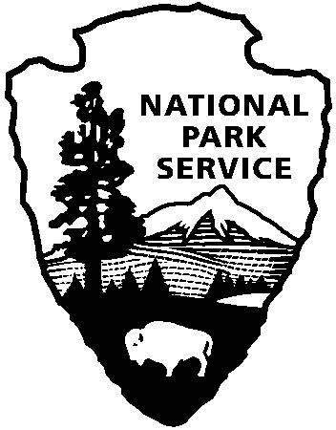

May 9, 2013
FOR IMMEDIATE RELEASE
Contact: Randy King, Superintendent, Tracy Swartout, Deputy Superintendent

IMPACTS OF SEQUESTRATION AT MOUNT RAINIER NATIONAL PARK

Effective March 1, 2013, Mount Rainier National Park was required to reduce its annual operating budget for Fiscal Year 2013 (FY13) by five percent due to the impacts of “sequestration” (a series of automatic, across-the-board permanent spending cuts). The park must absorb this funding cut between now and September 30, the end of the federal budget cycle, during the period when most visitors come to the park. The National Park Service’s FY13 operating budget was subsequently cut six percent under the continuing resolution passed by Congress later in March. This additional one percent cut to the National Park Service budget will be taken from projects at a national level, not park operating funds.
Mount Rainier’s annual budget last year (in FY12) was $12.08M. This included funding administered by Mount Rainier for human resources and resource Inventory and Monitoring (I&M) programs supporting many national parks in the Pacific Northwest, leaving $11.35M for Mount Rainier operations. From this budget, the park is eliminating $603,000 in planned FY13 expenses to meet the five percent mandated sequestration cuts, resulting in $10.75M available for the year. This year’s reduction is in addition to over $500,000 in operating budget cuts absorbed by the park since 2010.
To reach the new FY13 budget target, the park will take several measures:
Staffing Reductions: Anticipating some level of budget cut in FY13, park management put a hiring freeze in place last summer for most vacancies, excepting positions related to public safety and access. Typically, 78 – 80% of the park’s base budget is committed to personnel, with another 10% in largely fixed costs for fuel, utilities and fleet operations.
- More than a dozen permanent positions are currently vacant out of approximately 110 full and part year positions. Several of these positions will not be filled this fiscal year or next.

Support Cost Reductions: The park has eliminated most travel and training, and restricted supply purchases.
Visitor Services Reductions: Less funding equates to fewer staff to support visitor services.
- The Ohanapecosh Visitor Center will not open this summer. Closure of the Ohanapecosh Visitor Center (OVC) will impact approximately 60,000 to 85,000 visitors during the 130 days that the OVC would normally open each summer. This closure will also result in the elimination of formal interpretive programs and informal roving interpretation in the Ohanapecosh area (approximately 400 visitor programs/contacts for 27,000 visitors annually). Uniformed presence will be reduced in the surrounding area, including Grove of the Patriarchs and Box Canyon. The public restrooms outside the visitor center will remain open.
- Ohanapecosh Campground- shortened season by two weeks
The Ohanapecosh Campground will close two weeks earlier, on September 29 instead of October 14, resulting in the loss of approximately 680 camper nights.

- Cougar Rock Campground- shortened season by six weeks
By opening Cougar Rock Campground four weeks later (June 27 instead of May 24) and closing two weeks earlier (September 29 instead of October 14), the park would impact the least number of visitors and be able to wait until more of the snow is melted before taking on clearing activities. The delayed opening also enables an early start on a power line replacement project. Total camper nights impacted by the six week season reduction are estimated at 1,700-1,800.

- Carbon River Contact Station- staff reduction
In order to meet target reductions for FY2013, Mount Rainier National Park will reduce the number of seasonal fee collectors from three to two in the Carbon River Contact Station. It is expected that this staffing reduction will diminish hours that the contact station can be staffed, reducing availability of information, trip planning services, general assistance, and fee collection.

Absent additional funding next fiscal year, the $603,000 reduction is a permanent adjustment to Mount Rainier’s operating budget. Further adjustments in staffing, operations and visitor services will be made next fiscal year as park managers seek to optimize use of available funding to best serve visitors and protect Mount Rainier’s incredible resources.
“We’ve had to make some difficult yet necessary adjustments in operations this year, and have strived to minimize the impact of those decisions on visitors. The park will be open and accessible and will continue to provide an array of outstanding experiences and services. We look forward to welcoming people to their park this summer,” said Superintendent Randy King.
About the National Park Service: More than 20,000 National Park Service employees care for America’s 401 national parks and work with communities across the nation to help preserve local history, create close-to-home recreational opportunities, and generate over $30 billion dollars in economic benefits to the national economy. Learn more at www.nps.gov.
-NPS-

